**Research gap:**

1. Striped Region Distortion (SRD) in the context of ML-based image compression in the reconstructed image.
2. We are standardizing end-to-end compression architectures in deep learning. Current literature suggests optimal results when training and testing are both on GPUs or both on CPUs, highlighting the need for standardized models accommodating diverse hardware configurations.
3. Limited GPU resources often lead to out-of-memory (OOM) issues during full-resolution inference, particularly with transformers-based frameworks. To mitigate these problems, block partitioning is a viable solution, effectively reducing block duplication and alleviating block-related effects.
4. Aliasing effect in learning-driven lossy image compression frameworks, particularly in CNN and CAE-based architectures. Aliasing arises from directional pattern variations in reconstructed images.

**Signal processing methods:**

1. **JPEG compression and decompression**

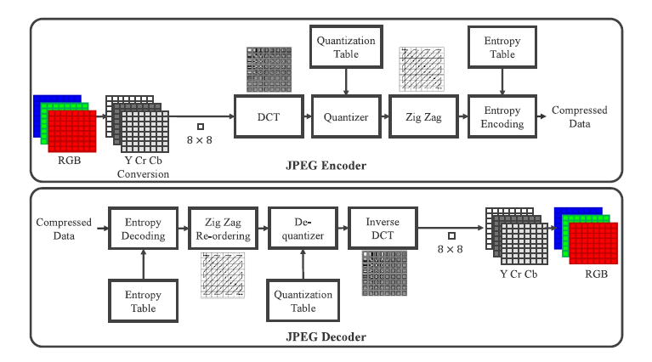

1. **JPEG-2000 compression and decompression:**

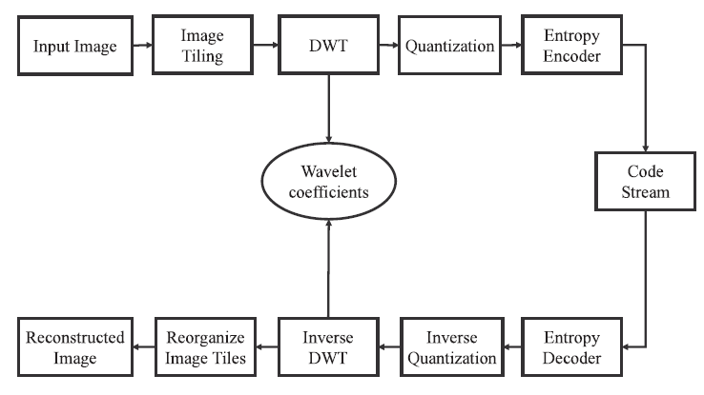

**DEEP LEARNING METHOD :**

**Image Compression with Variational Autoencoder (VAE):**

